Name____latia__________________________
Date___________2/8/11___________________
TV Studio – Matching Activity

Please label each piece and what it does.

This records people or things this controls the computer (hard drive)
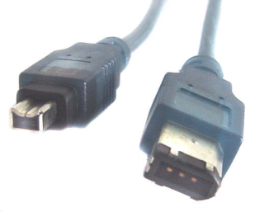
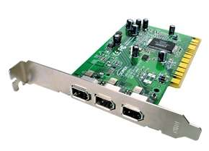
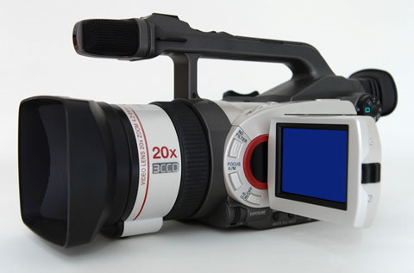
(video camera)

This is a computer and desktop
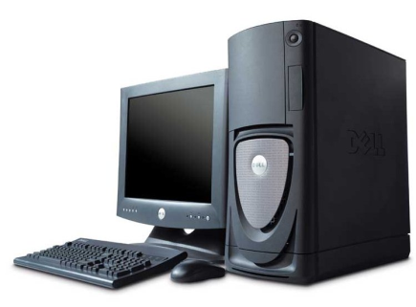
This is a fire wire drive (connects to computer and camera)

